PROJECT REPORT

ACKNOWLEDGEMENT

I express my sincere gratitude to the management of Rajagiri College of Social Sciences for providing the facilities and resources necessary for the successful completion of this project.
I would like to express my heartfelt thanks to my project guide Ms. Ann Rija for her valuable guidance, continuous encouragement, and constructive suggestions throughout the course of this project work.
I also extend my sincere thanks to the Head of the Department, Department of Computer Applications, for their support and motivation.
I would like to thank all the faculty members of the department for the knowledge and guidance imparted during the course of study.
Finally, I thank my family and friends for their constant support and encouragement, which helped me complete this project successfully.
Sivalakshmi P S

ABSTRACT

The rapid growth of digital transportation services has significantly changed the way people book and manage travel. Online bus booking systems have emerged as an efficient solution for passengers to search routes, reserve seats, and make payments conveniently.
This project titled “Bus Ticket Booking System” focuses on the design and development of a frontend-based web application that enables users to search buses, select seats, register and log in, and proceed to checkout securely. The system also includes an admin interface for managing buses, routes, schedules, and fares.
The frontend of the system is developed using modern web technologies such as HTML, CSS, JavaScript, and React.js, with emphasis on usability, responsiveness, and modular design. User authentication, seat selection, passenger details entry, and payment workflow are simulated using frontend logic and browser storage.
An admin module is included to demonstrate administrative privileges such as adding, editing, and deleting bus details, modifying routes, timings, and fare structures. Backend services are assumed and represented using mock data, as backend integration is outside the scope of the current academic phase.
This project demonstrates how a well-designed frontend can enhance user experience, improve accessibility, and provide a strong foundation for a complete full-stack online bus booking system.

Overview of the Project

With the rapid advancement of information technology and the widespread availability of the internet, traditional ticket booking systems have gradually evolved into digital platforms. Transportation services, especially bus travel, continue to play a vital role in connecting cities and towns, particularly in regions where buses remain the most economical and accessible mode of transport. However, conventional bus ticket booking methods often involve manual processes, long waiting times, lack of real-time seat availability, and limited flexibility for passengers.

The Bus Ticket Booking System is developed to address these challenges by providing a user-friendly, efficient, and web-based platform for booking bus tickets. The system enables users to search for buses based on source, destination, and travel date, view detailed information about routes, timings, bus types, and fares, and select seats according to their preferences. This digital approach significantly reduces manual effort and enhances user convenience.

The project primarily focuses on the frontend development of the application using React.js and modern web technologies. The application is implemented as a single-page application (SPA) to ensure smooth navigation and faster performance. It includes key features such as user registration and login, bus search, seat selection, passenger detail entry, checkout, and invoice generation.
Additionally, an admin module is provided to manage bus details, schedules, routes, and fare structures. Although backend and real-time payment integration are not included, the project effectively demonstrates a scalable foundation for a complete online bus booking system.

1.2 Objectives of the Project
The primary objectives of this project are as follows:

- To design a user-friendly and responsive frontend for an online bus booking system
- To allow users to search buses based on source, destination, and travel date
- To implement seat selection and passenger detail entry
- To provide secure login and registration functionality
- To restrict checkout access to logged-in users
- To provide an admin interface for managing buses, routes, schedules, and fares
- To demonstrate frontend development concepts using React.js

1.3 Scope of the Project
The scope of this project is limited to frontend development. The system includes:
- User registration and login
- Bus search and filtering
- Seat selection and passenger information management
- Checkout and payment simulation
- Admin dashboard for bus management
Backend features such as database connectivity, real payment gateways, and server-side authentication are not implemented and are considered future enhancements.

LITERATURE SURVEY

2.1 Overview of Bus Ticket Booking System
The Online Bus Booking System is a web-based application designed to simplify the process of booking bus tickets. It allows users to search buses by route and date, view available schedules, select seats, and complete bookings efficiently.

The system also includes user authentication and an admin module to manage bus details, routes, timings, and fares.

The application is developed using React.js to provide a smooth and user-friendly experience.

2.2 Study of Existing Bus Booking Platforms
Several popular online bus booking platforms such as RedBus, AbhiBus, and MakeMyTrip are widely used by passengers across the country. These platforms provide features like real-time seat availability, route selection, bus timing details, and fare comparison. They also support multiple payment options including debit cards, credit cards, UPI, and net banking. Due to these features, they have become reliable solutions for online bus ticket booking.
Although these platforms are feature-rich, they often suffer from overly complex user interfaces. New users may find it difficult to navigate through multiple filters, pop-ups, and advertisements displayed on the screen. The presence of excessive promotional content can distract users from the main booking process. This complexity may reduce user satisfaction, especially for first-time users.
Another drawback observed in existing systems is the lack of customization and clarity in seat selection and passenger details entry. Some platforms require users to go through many steps before completing a booking. This can increase the time taken to book tickets and may lead to confusion. Additionally, unnecessary options and recommendations can overwhelm users during the booking flow.
These limitations influenced the design of the proposed bus booking system. The focus was placed on creating a clean, simple, and user-friendly interface with minimal distractions. Only essential features required for booking were included to improve usability. The aim is to provide a smooth booking experience while maintaining all necessary functionalities.

2.3 Comparative Analysis of Existing Systems
A comparative analysis of existing online bus booking systems highlights both their advantages and shortcomings. Most current platforms offer essential features such as bus search, seat selection, route details, and online payment facilities. However, many of these systems suffer from complex user interfaces, excessive advertisements, and limited administrative control, which negatively impact the overall user experience. In several cases, customization options for managing buses, fares, and schedules are restricted, making system maintenance less flexible.
The proposed system is designed to overcome these limitations by providing a clean, simple, and user-friendly interface for passengers, along with a dedicated admin dashboard for effective management. Emphasis is placed on responsive design, clear navigation, and modular components to ensure smooth usability across devices. The system allows administrators to manage bus details, routes, schedules, and pricing efficiently. This comparative study helped identify key gaps in existing solutions, which were addressed during the design and implementation of the proposed bus booking system.

SYSTEM ANALYSIS

3.1 Existing System
The existing bus booking system is largely dependent on manual processes or partially automated online platforms. In traditional systems, passengers are required to visit bus counters physically to inquire about routes, seat availability, timings, and fares. This approach is time-consuming, inefficient, and prone to human errors such as incorrect seat allocation or fare calculation. Even in some online platforms, information is often fragmented across different pages, making navigation difficult for users.
Additionally, many existing systems do not provide real-time updates on seat availability, leading to booking conflicts and poor user experience. Administrative tasks such as updating bus schedules, modifying routes, or managing fares are often handled manually or through outdated interfaces. These limitations result in reduced efficiency, lack of transparency, and inconvenience for both passengers and administrators.

3.2 Proposed System
The proposed system introduces a centralized, web-based bus booking platform that simplifies the ticket booking process for passengers and streamlines administrative operations. Passengers can search for buses based on source, destination, and travel date, view available buses, select seats, enter passenger details, and proceed to checkout through a user-friendly interface. The system ensures that only registered and logged-in users can complete the booking process, thereby enhancing security.
For administrators, the system provides a dedicated admin dashboard with special privileges. Admins can add new buses, edit existing bus details, update routes, timings, boarding and dropping points, and modify fare structures as needed. This centralized control improves efficiency, reduces manual effort, and ensures that all data remains consistent and up to date. Overall, the proposed system enhances usability, accuracy, and reliability compared to the existing system.

3.3 Feasibility Study

Technical Feasibility
The proposed system is technically feasible as it is developed using modern and widely supported technologies such as React.js, HTML, CSS, and JavaScript. These technologies ensure smooth performance, responsiveness, and ease of future enhancements. The system architecture supports scalability and can be easily integrated with a backend or database in the future.

Economic Feasibility
The project is economically feasible since it relies entirely on open-source tools and libraries, eliminating licensing and subscription costs. Development and maintenance costs are minimal, making the system cost-effective for long-term use.

Operational Feasibility
The system is designed to be simple and intuitive, ensuring ease of use for both passengers and administrators. Minimal training is required, and users can interact with the system efficiently without technical expertise.

3.4 Functional Requirements
- The system must support user registration and login functionality to ensure secure access.
- Users should be able to search buses using source, destination, and date filters.
- The system must allow seat selection and entry of passenger details based on the number of seats selected.
- Checkout functionality should be restricted to logged-in users only.
- The system must include an admin login with special privileges.
- Administrators should be able to add, edit, and delete bus details, update schedules, routes, and fare information.

3.5 Non-Functional Requirements
- The system should have a responsive design to support multiple devices such as desktops, tablets, and mobile phones. It must provide a user-friendly and visually appealing interface to enhance user experience.
- Fast navigation and smooth transitions between pages are essential to reduce user effort. The system should be scalable to allow future enhancements such as backend integration, payment gateways, and database connectivity.

SYSTEM DESIGN

4.1 Architectural Design
The proposed system is designed using a component-based architecture implemented with React.js, which allows the application to be divided into independent, reusable, and manageable components. Each major functionality of the system—such as user authentication, bus search, seat selection, checkout, invoice generation, and admin management—is developed as a separate component. This approach improves code reusability, maintainability, and scalability.
The architecture follows a modular design, where components interact with each other through well-defined props and state management. For example, the bus search component passes selected route data to the bus results component, which further transfers selected bus details to the seat selection and checkout modules. This clear separation of concerns ensures that changes in one module do not directly affect other modules.
Additionally, routing is handled using React Router, enabling smooth navigation between different pages such as Home, Bus Results, Seat Selection, Checkout, Invoice, and Admin Dashboard without reloading the page. The system also uses browser storage (localStorage) to manage user login state and admin privileges. Overall, the architectural design ensures flexibility, efficient data flow, and ease of future enhancements such as backend integration and database connectivity.

4.2 Use Case Diagram
The proposed system is designed using a component-based architecture implemented with React.js, ensuring modularity, reusability, and ease of maintenance. Each major function such as bus search, seat selection, checkout, invoice generation, user authentication, and admin management is developed as an independent component. React Router is used to enable smooth navigation between pages without reloading, improving overall user experience. Data flows through the application using props, state management, and navigation state to maintain consistency across different stages of booking. User authentication is handled using local storage to restrict access to sensitive features like checkout and payment. The system clearly separates user and admin roles, allowing admins to manage buses, routes, schedules, and fare structures securely. This design improves scalability and allows future enhancements such as backend integration and database connectivity. Overall, the system architecture ensures efficiency, security, and a responsive user interface across devices.

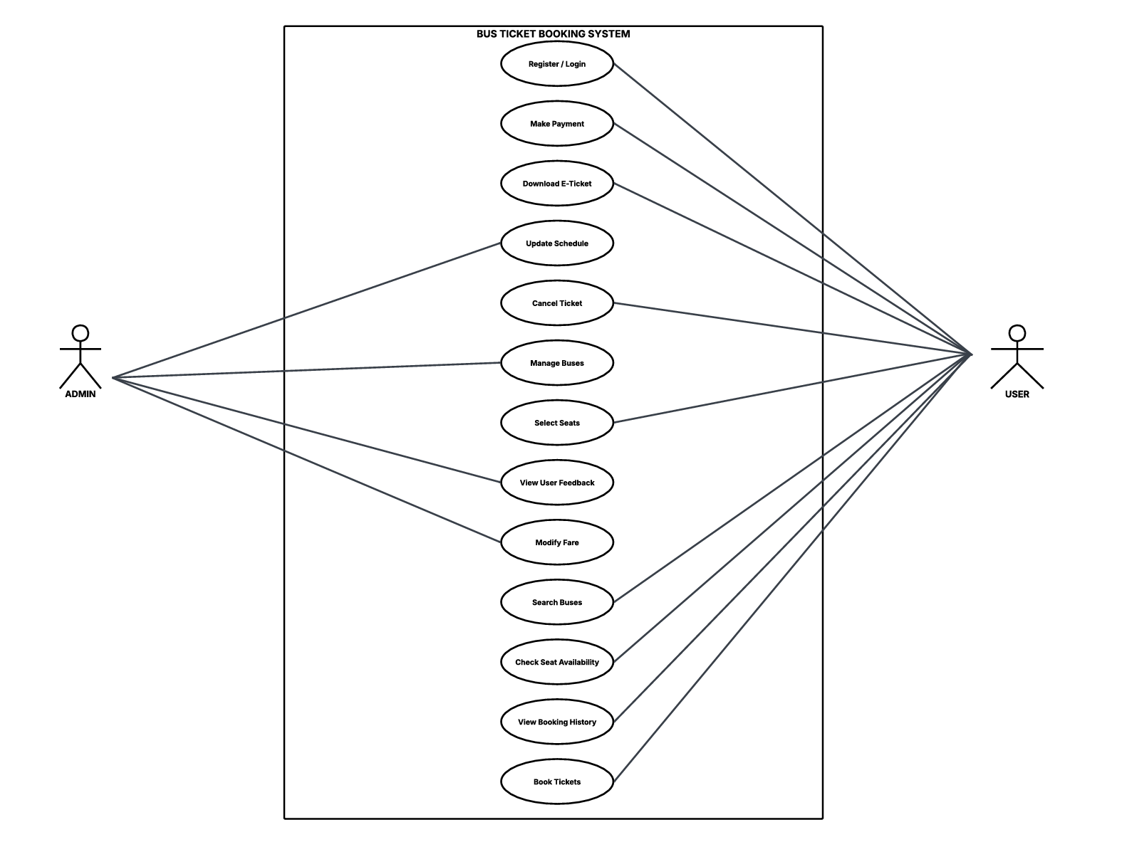

4.3 Sequence Diagram

The sequence diagram illustrates the step-by-step interaction between users, the system interface, and internal modules during the execution of key functionalities in the Bus Ticket Booking System. It represents the logical flow of actions such as user login, bus search, seat selection, checkout, payment processing, and invoice generation. The diagram also highlights the admin workflow, including authentication and bus management operations like adding, editing, and deleting bus details. By visualizing the order of interactions and message exchanges, the sequence diagram helps in understanding system behavior, data flow, and role-based access control. This ensures clarity in system operations and supports effective implementation and future scalability.

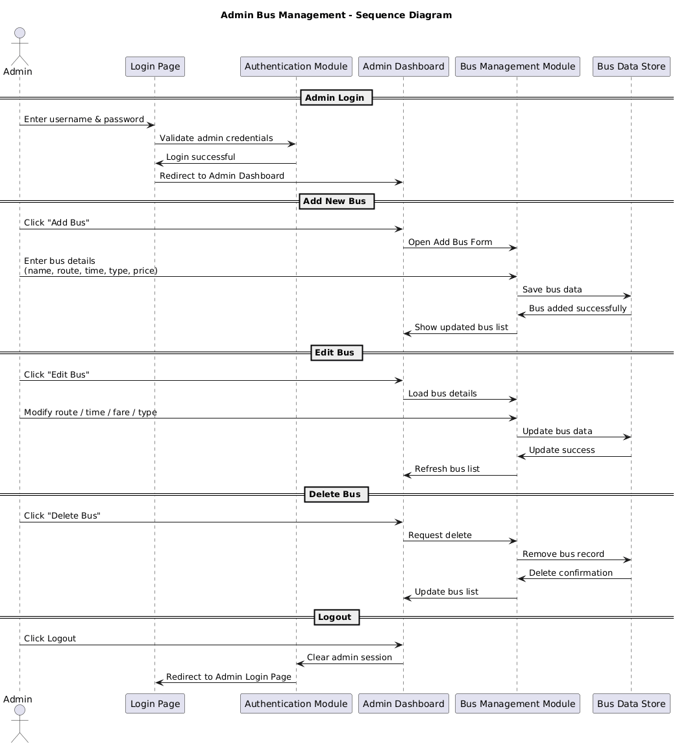

4.4 Activity Diagram
The activity diagram represents the workflow of the Bus Ticket Booking System by illustrating the sequence of activities performed by both users and administrators. It begins with user authentication, followed by bus search, seat selection, passenger detail entry, checkout, payment processing, and ticket generation. Decision points such as login validation and seat availability are clearly depicted to show alternate flows within the system. The diagram also outlines admin activities including login, bus management, route updates, schedule modifications, and fare adjustments. By visualizing the control flow and parallel activities, the activity diagram provides a clear understanding of system functionality, process logic, and role-based operations, ensuring smooth interaction and efficient system execution.

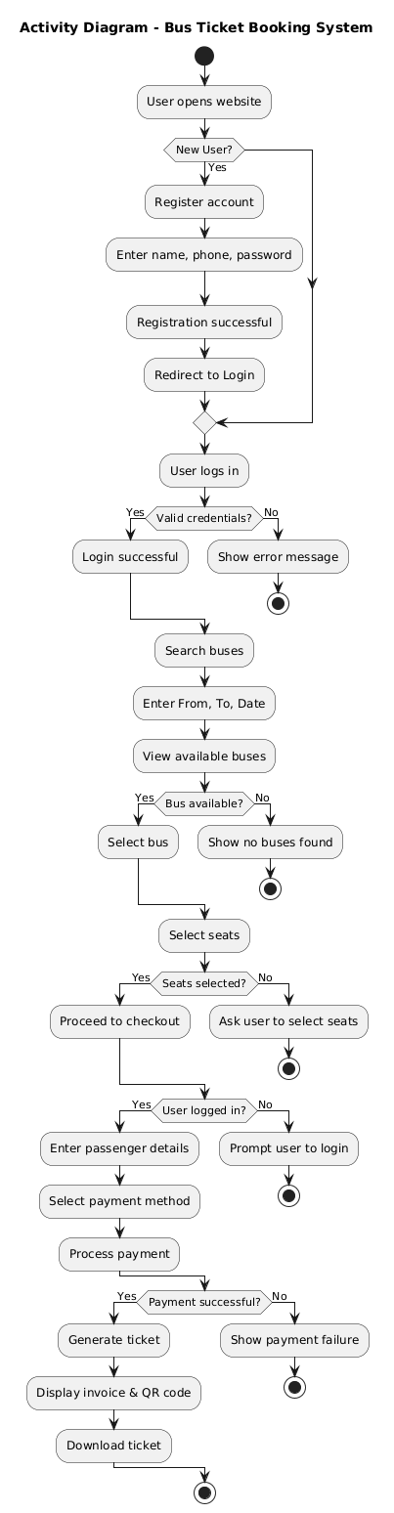

FRONTEND TECHNOLOGY STACK

5.1 Overview of Technology Stack
The frontend of the Bus Ticket Booking System is developed using modern web technologies that support interactive user interfaces, responsiveness, and efficient client-side processing. The chosen technology stack ensures smooth navigation, real-time updates, and an enhanced user experience across various devices. Since the scope of the project primarily focuses on frontend development, the selected tools are optimized for handling user interactions, interface design, and state management effectively.
The project adopts the MERN stack approach, with emphasis on the frontend components. Technologies such as HTML, CSS, JavaScript, and React.js are used to build a dynamic single-page application. These technologies collectively provide a scalable and maintainable structure, enabling easy expansion of features such as seat selection, checkout flow, user authentication, and admin dashboard functionalities.

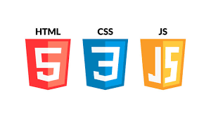

5.2 HTML (HyperText Markup Language)
HTML is used as the core markup language for structuring the web pages of the Bus Ticket Booking System. It defines the basic layout and organization of the application, including navigation bars, forms, buttons, cards, tables, and textual content.
In this project, HTML elements are utilized to design key interfaces such as user login and registration modals, bus search forms, seat selection layouts, checkout pages, invoice views, and the admin dashboard. Semantic HTML tags are applied wherever possible to improve accessibility and readability. The structured nature of HTML ensures seamless integration with CSS for styling and JavaScript for interactivity.

5.3 CSS (Cascading Style Sheets)
CSS is used to enhance the visual appearance and layout of the application. It controls styling elements such as colors, fonts, spacing, alignment, and overall page structure. The application uses CSS to maintain a consistent design theme across all pages, improving usability and visual coherence.
Responsive design techniques are implemented using CSS to ensure the system functions correctly on desktops, tablets, and mobile devices. Bootstrap is also utilized to speed up layout development and provide pre-designed UI components. Proper use of CSS improves readability, aesthetics, and overall user satisfaction.

5.4 JavaScript
JavaScript plays a crucial role in adding interactivity and client-side logic to the application. It enables dynamic updates, form validations, event handling, and conditional rendering of components without reloading the page.
In the Bus Ticket Booking System, JavaScript is used to manage user inputs, handle search operations, validate passenger details, control login sessions, and simulate backend interactions using stored data. It also helps in handling role-based access, such as restricting checkout functionality to logged-in users and providing special privileges to admin users.

5.5 React.js
React.js is a JavaScript library used for building fast and interactive user interfaces, especially for single-page applications. It allows developers to create reusable UI components and manage application state efficiently using hooks.
In this project, React.js is used to structure the application into modular components such as Home, Search Results, Seat Selection, Checkout, Invoice, Login, Register, and Admin Dashboard. React Router is used for navigation between different pages without full page reloads. The use of React’s virtual DOM improves performance by updating only the required parts of the user interface. Overall, React.js enhances scalability, maintainability, and performance of the Bus Ticket Booking System.



FRONTEND IMPLEMENTATION
The frontend of the Bus Ticket Booking System is developed using React.js, following a modular and component-based architecture. The user interface is designed to be responsive, intuitive, and user-friendly, ensuring smooth interaction across different devices. Bootstrap is used for styling and layout, while React Router enables seamless navigation between pages without full page reloads. The frontend handles all user interactions, validations, and role-based access control efficiently.

6.1 User Authentication
The system provides secure user registration and login functionality to control access to booking and payment features. During registration, users are required to enter personal details such as full name, email, phone number, and password. Upon successful registration, users are redirected to the login interface.
The login process uses the registered username and password for authentication, and the login status is stored using browser local storage. Only authenticated users are allowed to proceed to the checkout and payment stages. Logout functionality is also implemented to allow users to securely exit the session. Visual feedback such as success messages and alerts enhances user experience during authentication.

6.2 Bus Search & Seat Selection
The bus search module allows users to search available buses by selecting source city, destination city, and journey date. City suggestions are provided using dropdown inputs to reduce typing errors, and a swap button enables users to interchange source and destination easily.
Search results are displayed dynamically, showing available buses along with route details, timings, duration, seat availability, and fare. Users can then proceed to the seat selection page, where an interactive seat layout is displayed. Seats are visually differentiated as available, selected, or booked. Users can select multiple seats, with a limit enforced per booking, and seat selection updates in real time.

6.3 Checkout Module
The checkout module is accessible only to logged-in users, ensuring secure booking flow. If a user attempts to proceed without logging in, the system prompts them to log in first.
At checkout, users must provide mandatory passenger details for each selected seat, including name, gender, and age, while email and phone number are required only once for contact purposes. Input validation ensures that all required fields are completed before proceeding. Users can then choose a payment method using visually represented card options. Only after successful validation can users proceed to payment and invoice generation.

6.4 Admin Module
The system includes a dedicated Admin Module with role-based access control. Admin users can log in using predefined admin credentials and are redirected to the Admin Dashboard upon successful authentication.
The admin dashboard allows administrators to add new buses, edit existing bus details, update routes, schedules, timings, and fare structures, and delete buses when required. All bus data is displayed in a structured table format for easy management. This module ensures that only authorized personnel can manage operational data, maintaining system integrity and reliability.

